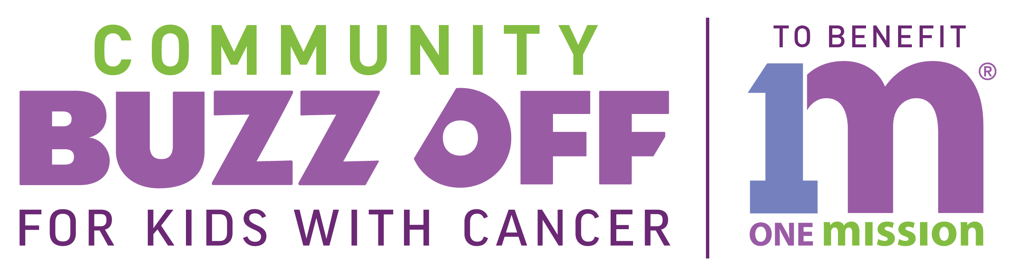

FOR IMMEDIATE RELEASE CONTACT:
YOUR NAME:
YOUR EMAIL:
YOUR PHONE:

[TOWN NAME] RESIDENT TO SHAVE HEAD AT
BUZZ OFF TO BENEFIT ONE MISION ON {DATE/LOCATION HERE}
Event will benefit One Mission, a pediatric cancer charity

[TOWN HERE] Resident [YOUR FIST AND LAST NAME HERE] will shave their heads to support kids with cancer, kids who don’t have the choice to lose their hair. Proceeds will fund programs and services that make life brighter for kids fighting cancer and their families. Programs like music and art therapy, birthday parties and holiday celebrations, hospital room makeovers, toys, games and much, much more.

[NAME HERE] is actively seeking donations to support [HIS OR HER] heroic efforts by raising as much money as {HE OR SHE} can.

“IN THIS SPACE PLEASE WRITE A QUOTE ON WHY YOU DECIDED TO BUZZ. WAS IT BECAUSE YOU OR SOMEONE YOU LOVED WAS AFFECTED BY CANCER OR JUST WANTED TO HELP? ”

To sponsor [FIRST AND LAST NAME HRE] or to learn more information on how you can join The Buzz Off, please visit www.buzzforkids.org.

About One Mission
One Mission is a pediatric cancer charity that does whatever it takes to get kids through cancer treatment. One Mission’s programs and services reduce stress, restore joy and help patients and their families get through the emotional and financial challenges of treatment. Since 2009, One Mission has raised more than $14.6 Million dollars and has brought smiles, comfort and support to over 36,000 kids fighting cancer and their families.

###

